http://www.onlinechineseastrology.com/three-blessings-report/report.aspx?Guid=BF1BC3D3-4A9B-4EA5-B1FB-5ED27CD5C380

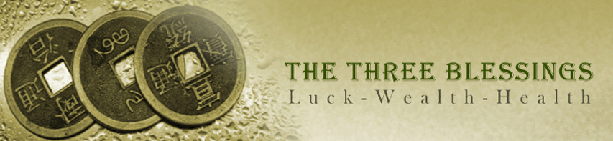
Download as PDF
Three Blessing Reading for Bill
Report created by Bill Hajdu
Birth Date and Time: February 06, 1947 1:00 PM
Your Chinese Astrology Signs:
Year: | Fire Pig
Month: | Water Tiger
Day: | Fire Dragon
Hour: | Wood Sheep
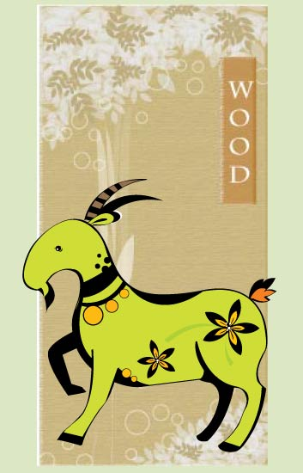
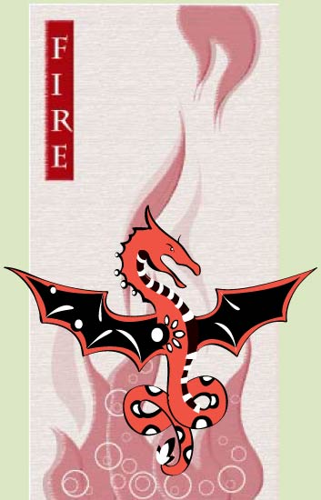
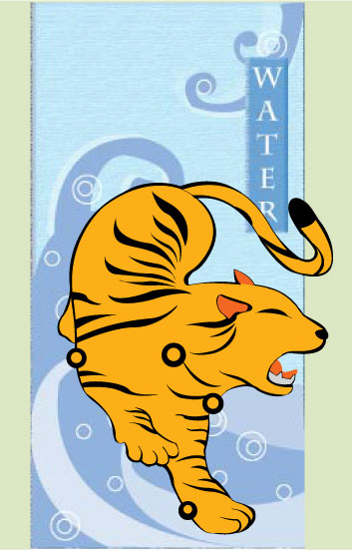
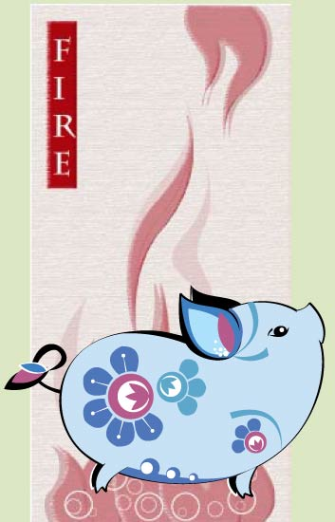
Background

Happiness, Wealth and Longevity (Fu Lu Shou) – the three great blessings of life. At least that’s what Chinese have believed for thousands of years. Phouc Loc Tho in Vietnamese. Guess what stands at the entrance of the Asian Garden Mall in Little Saigon, Westminster, California? Would you believe statues representing The Three Blessings! In fact the locals' popular name of the mall is Phuoc Loc Tho.

I bet you’re like most people. You want your share of them. And that’s not all. It’d be nice to know how to get the best from whatever blessings fortune has given you.

Think about this. You get a blessing. So what? That’s an area of your life that’s likely to give you plenty of enjoyable moments, to make you say life is good. Seems to me here’s where you want to make a big effort. Take advantage of it.

Then there’s a neutral rating. I look at it this way. Not going to make me a winner or a loser if I just do the normal normal. Enjoy the benefits. Make a modest effort to deal with challenges.

Oops. Can’t hide from an unfavorable rating. Of course you’re not going to stand up and cheer. On the other hand it’s a good thing to know you’re facing this challenge. Know what pushing on a rope means? Sometimes you can make a big effort – over and over – and the results you want don’t come. I have a suggestion. No, it’s not give up. I say have the right attitude. It’s a case of not letting this area of your life let you down. Think about compensating and setting realistic goals. Still means you probably have to make a big effort here, just as you want to do with an area where you do have the blessing.

I hope you’re feeling blessed already. What I’m about to do for you, what you’re going to learn… Well, this kind of information was once available only to the emperor. Now all people have the ability to discover their Fate in terms of The Three Blessings. And, with this reading, you have it too.

Your Three Blessings Reading

I did this reading based on your Year, Month, Day and Hour (if known) of birth. Since forever the Chinese have believed your Fate is determined at that moment. But they don’t say everything’s set in stone. You can use the information in your chart to improve your life. Think about it. What could you do if you knew which areas of your life were blessed with good fortune?

Maybe the first thing you need to know about your reading is this. Think in terms of patterns and look for themes that keep coming up. You know -- people are complicated. No one comment can tell all. Now what I’ve done for you is pick indicators to show a tiny piece of the big picture. Ten for each of The Three Blessings. Some things you may see several times. Those are probably the biggies. Others only once. I wouldn’t forget about those; though, each can reveal something important about your life.

Another thing about these indicators. Don’t be surprised if one says exactly the opposite of another. There are reasons for this. As I’ve said, people are complicated. You’re not always going to react the same way – even if two situations are very similar. Has anyone said you’re unpredictable? I’d guess most people are to some extent. It’s the same with Good Fortune. Never all good or all bad.

And it won’t be the same in every area of your life. So by one indicator you could have good fortune and another not so much . Not a contradiction. After all, each of the blessings covers different things. Happiness is a perfect example. How many things make you happy? Some will be dependable while others come and go. Good fortune also varies according to age. Take Prosperity. Might happen early or rather late in life. A lucky few enjoy it lifelong. Or, your financial situation could keep going up and down. In the end it’s about your whole life. When all is said and done, will people say you were blessed?

Finally, within the boundaries of your Fate, you have wide freedom of choice. I mean what good is a blessing if you don’t take advantage of it? Choices you make. The effort you put in. Contributions of others. All these add to or reduce your potential for success.

By the way, I’ve expanded the meaning of the third blessing to include Health in general. And why not? Having good Health is likely to lead to long life. They go together.

Now for some admin. Here’s a quick outline of your reading. It’s divided into four parts, one for each of The Three Blessings and a brief, general conclusion. There’s a special section following it. Happiness is first. That’s what a good life is all about. And who doesn’t want to know about money?! No surprise it’s traditionally the second blessing. Finally there’s the blessing of long life. Hopefully there’ll be lots of good Health to make it really enjoyable. When I said the conclusion is brief, I meant it. Don’t get hung up on what it says. The details and recurring themes are more important.

A final word. Even if I tell you have all three blessings, some of the indicators will still be unfavorable. Not to worry. Even if you don’t receive any of The Three Blessings. You see I’ve added a special section after the conclusion. The whole point of it is to give ideas on how to make the most of whatever good fortune you have, big or small! And believe me. There’s plenty you can do.

1. | Happiness | 
2. | Prosperity | 
3. | Longevity | 
4. | General Conclusion
Each part of this reading contributes valuable information to help you discover your Fate. By now you might be coming to the conclusion that many factors go into your chart. You bet. There’s a lot more to Chinese astrology than knowing you’re a Dragon, reading a few lines, and thinking you’ve got it down. Even this report has only a tiny bit of what Chinese astrology can tell you.

Now begin a unique journey to explore your Fate.
Section 1 – Happiness
Introduction


And just what is Happiness? I bet if you asked all your friends, no two would give you the same answer!

I went to the internet to get an expert opinion. Funniest thing happened. Someone wrote: Defining happiness can seem as elusive as achieving it. Well that’s a big help. For me it’s different for everyone. So I say happiness is what happiness means to you. I can think of lots of things that might make you happy. Love. Beauty. Family. Nature. Learning. Excitement. Comfort. Not to mention the other two blessings, lots of money and good health.

Please keep in mind what I said before. You’re probably not going to get everything that could make you happy – and certainly not all the time. This is true even if you are blessed with Happiness. So don’t be surprised when you see different ratings on the indicators.

Finally, I want to say life itself is complicated. So’s an analysis of your Happiness. I use ten indicators from your chart to deal with that fact. Each has a little narrative. It tells you your rating and why you received it. I even give you a tip or two on how to compensate for the unfavorable ones. Then I give an overall evaluation saying whether or not you have the Happiness blessing.

The Indicators

Element mix

This first one’s about balance. How does that help? Easy. Fast action or a slow, cautious approach for example. Nice to be able to do it all. May look good to be super strong here, but what about that vulnerability there? So here’s what I get looking at the five elements in your chart:

2
2
4
2
2
They’re distributed as follows: 42222. This is balanced, showing one, strong and four, approximately average areas in terms of your capabilities and life stages. This is LUCKY, as you should have more than enough chi (energy/life force) to take advantage of opportunities and to deal with problems during your life.

Element cycle

Cycles touch your life in so many ways. What magic as Winter turns to Spring – and so it goes through the year until Winter returns. And that’s how it is with the five elements and your life cycle. Wood represents plants and new growth. So it’s the element properly associated with your birth and early childhood. But there’s a catch. Each of us has our own cycle -- determined by our date and time of birth. It may or may not be the same as the natural one. Great if it is – lucky. If not, it’s neutral or even unlucky depending on the relationship between your element and Wood. Here’s how you fare:

The first stage of your life cycle is ruled by the element, Water, which is not the natural element ruling new life. This is NEUTRAL, however, as Water has a harmonious relationship with the natural element, Wood. This relationship also exists in the remaining, four stages of your life, as your ruling element will be in harmony with the natural element in every, succeeding one.

Year of birth

Element

I know. Everyone’s thinking about your animal when they ask what’s your sign. But there’s more to it. Namely an element. It’s as much a part of your sign as that Snake or Dog or whatever. And it may or may not get along with the element that goes with your animal sign. For you that means:

Your birth year element, Fire, has a destructive relationship with your fixed element, Water. Water puts out Fire. This is UNLUCKY as it drains your chi (energy/life force), thereby decreasing your chance of success in life.

Animal

OK. I do want to talk about animal sign too.

Your Pig sign is LUCKY. You will have more than your fair share, which is a good thing, as you will probably need it depending on how much you exhibit the Pig's typical innocence and overly trusting nature.

Month of birth

I like to say your year sign is the first among equals. So let’s not forget about your month sign, one of those others demanding equal billing. For now I want to look at it this way. And that is… Some signs are just considered plain lucky in Chinese Astrology. How about yours?

You were born in the month of the Tiger, the first month of the lunar calendar. You have the good fortune to probably enjoy a fulfilling marriage and a rewarding career. Success could be yours in many areas if you do not become greedy. This indicator is, therefore, LUCKY.

Day of birth

I’m going to take a different approach with your day sign. For this one I’ll look to the stars. Chinese see 28 mansions or constellations in the sky. One of them ruled the day of your birth. To be honest, many of them are not very lucky. So if this indicator isn’t lucky for you, you just may be normal.

The constellation ruling your date of birth is K'uei, or Shoe, which is associated with the Wolf, West and sickness, and, therefore, UNLUCKY.

Hour of birth

In Western Astrology you hear a lot of talk about the ascendant. That’s nothing more than your hour sign. It’s important in Chinese Astrology too. And the fact is some of them are luckier than others. I’m not going to bother going into the reasons. You’ll have to trust me on this. Now let’s take a look at yours.

You were born during the eighth hour, which is UNLUCKY, especially in the area of relationships.

Happiness

One chart I do breaks up your life into five stages. Happiness plays a major role in one of them. Remember the five elements? Each one rules a stage. See where I’m going with this? Yup. If you have a lot of the element in the Happiness stage, you’re going to get a good rating here.

For you the moment of Opportunity is at Retirement, which is UNLUCKY. This, nevertheless, could be a positive development, but the benefits are more likely to accrue to your children than to you.

Childhood

Another indicator based on your life stages. Here I appeal to the father of psychoanalysis, the great Sigmund Freud. Yes, he stressed the importance of early childhood on personality development. So I take a look to see how strong your chi is during this crucial time of your life. Again, it’s the element that rules this stage. If you’ve got a healthy amount of it... lucky.

Your chi rating at Maturation is about average. This indicator is NEUTRAL. In terms of your energy level you are likely to have about the same chance of success as the majority of your peers as you embark upon your career.
Internal Sign Compatibility

How many times have you heard this oldie? No one can make you happy; happiness comes from within! How happy are you with yourself? Are you comfortable in your own skin? To answer these I take a look at how well your signs get along with each other. Remember, you have one for your year, month, day and hour of birth.

Your overall, internal compatibility is significantly above average, which is LUCKY. This can have a positive effect on your self esteem, self confidence and decisiveness, as the various aspects of your personality tend to be in harmony.

Conclusion
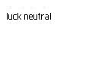
Time to add ‘em up.

You have four LUCKY, two NEUTRAL and four UNLUCKY indicators. Your fate is that you are neither LUCKY nor UNLUCKY. You will probably find you are luckier than some people and not as lucky as others. You will have your opportunities and your challenges, roughly in equal measure. You are going to have to work to achieve your goals, but at least fate is not against you. You will be more lucky than not at certain times and in different areas, but in the end you will have received your fair share of luck and no more.
Section 2 - Prosperity
Introduction

I’m talking money here. Material success. But, like Happiness, that means something different for everyone. How about you? Is your goal to have lots of it? Or is it more like being comfortable, not having to live from paycheck to paycheck? Don’t expect me to give you a definition of prosperity. I say it’s what you think it is. It’s your life!

And don’t be shocked with this one either. Your indicators are going to be favorable – and unfavorable! Think about it. What does prosperity include? First let me say the overall rating covers your whole life. I mean, who doesn’t have more money at some times and less at others?! And what about all the ways you can make money? It’s not realistic to expect to have it rolling in from every which way. I’m talking everything from the money you make at work, property, investments, even lottery winnings.

All I can say is if your good indicators are more than the bad ones, you’re blessed. I’d be surprised if you get all the money you want. Who does?! Still, I think you’ll be happy. And if you don’t get the blessing? No, it doesn’t mean you’re going to end up begging in the street. It just means you’re probably normal. You’re going to have to work for it. Enough said.

General Indicators

Yes, there are a couple of items in your chart that give me an immediate idea of your chances. Trust me. They’re there.

Your indicators have an above average rating and are, therefore, LUCKY. Financial success should come relatively easily to you if you apply yourself.

Your Signs

Here’s an indicator for each of your signs. Well, ok, I have two for your year sign. You see I always think of it as the first among equals and give it more weight.

Earthly Branch (animal of your year sign)

Don’t need to tell you; life isn’t always fair. Seems like some signs get more breaks than others, Tigers and Dragons for example.

In the West a wealthy person is sometimes referred to as a fat cat. In China they talk of the fat pig. Indeed, ceramic pigs grace many a Chinese business establishment. Money is likely to come your way, which is fortunate, as you may tend to easily spend and lose it. This indicator is LUCKY.

Heavenly Stem (element of your sign)

When I think of gold and silver, I see rich. And wouldn’t you know it. One of the five elements is Metal. So of course it’s the one indicating money. If you have it, advantage to you. Otherwise it depends on a relationship – one between your element and Metal. Favorable, a neutral rating. Destructive, an unfavorable one.

You were born in a Fire year. Fire has a destructive relationship with Metal, the element that best indicates money and the accumulation of wealth. This indicator is UNFAVORABLE.

Month sign

Here I’m just looking at the animal. My conclusion is based on the same reasons I gave for your year sign.

You were born in the month of the Tiger, the first month of the lunar calendar. This is a LUCKY indicator considering your potential to accumulate wealth. You have an excellent chance of achieving financial success as long as you don't get too greedy.
Day sign

Gonna switch gears here. Time to look to the stars. Each day of the lunar month is ruled by a constellation. To be honest it doesn’t have a lot of influence over your whole life. But enough… for me to use it as an indicator. A lot of them are not that favorable. So if your rating isn’t a good one, you’re probably – normal!

Your birth date is ruled by K'uei or Shoe, an unfavorable omen. It is associated with misfortune, quarrels and lawsuits, and, therefore, UNLUCKY.

Hour sign

Some hours are luckier than others. Take my word for it. I’m not going to go into the details here, but I’ll tell you about yours.

You were born during the eighth hour, which is associated with relationship difficulties likely to negatively impact finances and, therefore, UNLUCKY.

Means

What’s the best way for you to make money? Sales. Real Estate. Teaching. Caring for others. Face it; you’re suited for some careers and not others. Perhaps the most direct route to prosperity is commerce, being in business. Advantage to you if your chart says that’s the best way for you to go. If not, well you’re like most people. And a lot of them are successful following a different path.

According to your chart the best way for you to make money is in land or other property. This may or may not be way to financial success, so this indicator is NEUTRAL.

Opportunity

Do you hear opportunity knocking? I’m sure it will. The question is… what area of your life is it most likely to affect? You’ll get a favorable rating here if yours is directly connected with making money.

There is a chance you will derive considerable wealth from shrewd investments. If acted upon this signifies acquiring riches and should be considered a LUCKY indicator.

Maturation

I’m constantly using the five elements. That’s the Chinese way. So of course I divide your life up into five stages when I look at your chart. And when it comes to prosperity, I think of Maturation (the third stage) as being the most important. I’m talking about the time after you’ve finished your education. You’re heading out to start and build a career. Wouldn’t you want this to be a strong time in your life? I ask this question because your chi (energy/life force) isn’t going to be at the same level throughout the five. I mean, really, how helpful to your career would it be if your strongest time was retirement?! So how is your chi during those crucial years?

Your chi level at Maturation is low normal. This indicator is NEUTRAL.

Adulthood

Here’s a second chance. I want to talk about the fourth stage now, Adulthood. In prosperity terms it’s the time you’re making the most money from your work. As with Maturation, advantage to you if your chi is strong.

Your chi level at Adulthood is significantly above average. This indicator is LUCKY.

Conclusion

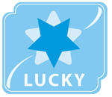
You have five LUCKY, two NEUTRAL and three UNLUCKY indicators. Fate has decreed you are LUCKY and have a good chance of becoming prosperous. Since there are three, unfavorable indicators, you could, however, experience some setbacks as well as successes. You have the potential to accumulate significant wealth. There is a good chance you will be comfortable in retirement.
Section 3 – Longevity
Introduction


So how long is long life? It’s different for men and women and from country to country. You can define it based on your personal situation. I’m just going to say it’s living longer than most of the people you went to school with. Seems to me this blessing is also about being generally healthy. I mean that’s one of the big reasons people live long. Putting this out there now as you’ll find plenty of comments about your health in this section.

General Indicators

Your chi (energy/life force) is reflected in your chart. Here I’m looking for its connection with health.

Your chi (energy/life force) rating for Health is slightly below average and, therefore, NEUTRAL. Although you should enjoy good health if you take proper care of yourself, you could have some health problems during stages when your energy level is low.

Your Signs

Again, here are the signs for your year, month, day and time (if known) of birth, the Four Pillars of Chinese Astrology.

Year

As I said before, I think of your year sign as the first among equals. Two indicators for this one.

Earthly branch (animal)

It may be unfair. Just the way it is. Some signs seem to have an advantage when it comes to enjoying a long life. Here’s my take on yours.

The Pig's love of physical pleasures can easily get them into Health difficulties if this becomes excessive, for example, over eating and gaining weight. The negative effect of this is heightened if you are not conscientious about an exercise program. A positive is you probably have an easy going nature, which helps reduce stress and high blood pressure. Overall this indicator is UNLUCKY.

Heavenly stem

The elements aren’t fair either. But, there’s a difference. I wouldn’t call any of them unlucky when it comes to longevity. Two of them probably give you an advantage. On the other hand if you have too little or too much of your year element, I can’t give you a good rating. You’ll get the best one if you have a high average amount of either Wood or Earth.

You were born in a Fire year. As a Fire sign you could have a tendency to be reckless and take unnecessary risks. Also, you may be susceptible to problems with the heart, small intestine and tongue. Given the modest amount of Fire in your chart overall, however, this indicator is NEUTRAL.

Month

Only one indicator here. I’m going with the animal sign.

You were born in the month of the Tiger, the first month of the lunar calendar. You are likely to experience a lot of happiness in your life, thus contributing to your good health and longevity. This indicator is, therefore, LUCKY.
Day

As before, I’m looking to the stars on this one.

Your birth date is ruled by K'uie or Shoe, an inauspicious constellation. It is associated with sickness and discord and is, therefore, UNLUCKY.
Hour

Is everyone who is born during a certain two hour period going to have a long life? Of course not. Remember the idea that applies throughout this reading. The indicators indicate; they don’t guarantee anything. It’s when you put them all together you can say yes, I have it! Having said that, I still say it’s an advantage to be born during some of them and not so good for others. And how about yours?

Your time of birth occurs between one and three PM, the eighth hour, which is UNLUCKY for health and longevity. A number of troubled relationships are likely to greatly diminish your energy.

Happiness

Two indicators here. The first is from your chart. I use your overall rating from the Happiness section of this report for the second.

Chart Indicators

I have two indicators that directly relate to Happiness. If you’re strong on those, that’s a big advantage when it comes to being healthy and living long.

Your chart shows this to be a slightly, below average area for you. This indicator is thus NEUTRAL.

Happiness Blessing

Remember your conclusion from the Section 1? It’s safe to say your overall Happiness affects your health and likelihood of living a long time.

From the first section you know you have four favorable and unfavorable indicators, with an overall rating of NEUTRAL. The positive and negative affects of these will probably cancel each other out as regards your achieving and maintaining good Health and longevity.

Longevity

Here I look at the final stage of your life, Retirement. What’s your chi (energy/life force) level like? A moderately high amount and you get a favorable rating.

In your later years your chi will be low normal, making this a NEUTRAL indicator.

Element mix

I always like to look at balance. It shows reasonable strength and no vulnerabilities. The best way to do it? See how much you have of each element. Any excesses? Shortages? Here’s your mix:

2
2
4
2
2
You have no element shortages. You are likely to be able to generally maintain good health throughout your life. This indicator is therefore LUCKY.

Conclusion
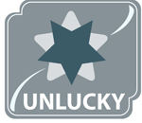
You have two LUCKY, five NEUTRAL and three UNLUCKY indicators. You do not have the good fortune of having a better than average chance of enjoying good health and a long life. Since there are two, favorable indicators, you can expect some bright spots. Generally, however, your health will probably not be a plus when it comes to your achieving your goals and enjoying life, giving you an overall rating in this area of UNLUCKY.
Overall Conclusion
Fate has neither favored nor forgotten you when it comes to receiving your share of The Three Blessings. You are likely to find that you experience good and bad luck in about equal measure. This means the success and happiness you achieve in life depends as much on your hard work as on how lucky you might be. You will notice many people are more lucky than you, but you will also find plenty who are not.
Appendix 1 - About Chinese astrology
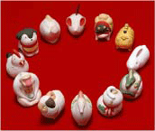
The roots of Chinese astrology go back thousands of years. Needless to say in the course of millennia a number of different systems have been used. There are two main types, those that rely on birth data alone, and those that use birth data but rely primarily on positioning of stars and planets. Most use the lunar calendar (see appendix 1 for more info on the Chinese calendar) which bases its calculations on the cycles of the moon. That is why Chinese New Year falls on a different date every year. Some Chinese systems use the solar year as Western astrology does. Both, however, make use of Chinese five element theory. The five elements are Wood, Fire, Earth, Metal, and Water, always being given in that order. It is said to be a productive cycle, that is Wood produces Fire; Fire produces Earth; Earth produces Metal, Metal produces Water, and Water produces Wood, thus continuing the cycle. The balance of these elements and their positioning in a Chinese chart determine many components of a person's luck and fate. Chinese astrology is a complicated set of systems of analysis, which is not unlike life itself. It rarely yields a simple answer. Even when there is a single indicator, it does not tell the whole story. A person's health, for example, is likely to vary over the course of a lifetime. Overall health may be rated good, but during a period of weak chi a person could still be susceptible to problems. There is one more very important thing to know about Chinese astrology. Chinese astrologers are not strict determinists. In other words they do not believe a person’s fate is sealed in stone at the moment of birth. What they do believe is that a person’s time and place of birth set parameters, boundaries within which a person has more or less freedom. What happens within these boundaries is influenced not only by free will but also by external indicators such as financial status of the family, the culture, and the local economy. In one way this is just common sense, not unlike what people in the West already believe. If your adult height is five feet one inch, you’re not likely to be a professional basketball player. If your IQ is less than 100, you’re not likely to be a chemical engineer. There is of course a whole body of Chinese philosophy and culture underlying the precepts and findings of Chinese astrology. The subject of Chinese studies, as fascinating as it is however, is well beyond the scope of this basic introduction. One point worth mentioning, though, is that balance plays a central role in Chinese thought. Even this idea has Western counterparts, Aristotle’s golden mean for example. In Chinese thought a star athlete who flunks Algebra is still weak. True strength comes from balance. A strong chart will be balanced in terms of both signs and elements. Ideally a person will have, for example, a mix of strong and gentle signs as well as of elements. And, if a person has a variety of signs as opposed to, say, two Monkey and two Pig signs, so much the better. That means the person has a wider range of capabilities. Much of the above discussion has been about personality and abilities. Originally, however, the primary purpose of Chinese astrology was fortune telling. The focus is usually on what will happen to people in various stages of their lives or a specific duration of time, or on what people should do on a particular day or in a certain month or year. Most of the information you will find in English on Chinese astrology will be about personality. This reading does not address that area. It is strictly about your Fate. Please understand, however, that there is no magic bullet, no single answer. Human life is complicated; there are ups and downs. People enjoy good luck as well as bad.
Appendix 2 - The Chinese Calendar
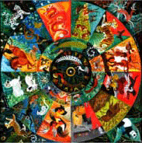
The Chinese calendar differs significantly from the Western calendar. The primary difference is that the months of the Chinese calendar are directly tied to the phases of the moon. These phases, however, do not fit in with the length of the year as measured by the Earth’s revolution around the sun. The Western calendar is fixed in the sense that each New Year begins on solar/Western calendar date January first. Because the Chinese New Year must correlate with a moon phase, it falls as early as January 22nd and as late as February 19th on the Western calendar. This has significant implications for Chinese Astrology. First, however, it’s important to understand the primary difference between Chinese and Western astrology. Chinese astrology focuses on the year sign, and Western astrology focuses on the month sign (Aquarius, Pisces, etc.). Chinese astrology does, however, have month signs. This can be confusing because the month signs have the same name as the year signs. Furthermore, when we say a Chinese sign corresponds to a Western sign, e.g., Ox to Capricorn, we do not mean the person was born in a Capricorn month. Rather, we mean the person’s Chinese year-sign traits roughly correspond to the traits of that Western sign. Adding to the confusion is the fact we can’t know a person’s Western sign simply by knowing the person’s Chinese month sign. For example, a person born on the first day of the seventh month (July 1 in Western terminology) of the Chinese calendar year 1979 was actually born on August 23rd of the Western calendar. Since July 1st is Cancer and August 23 is Leo, it’s easy to see the confusion. As with the months, neither do Chinese and Western years match exactly. Thus, even though we might know a person’s Chinese sign, we still cannot be sure of their year of birth. Conversely, if we know a person’s year of birth, we cannot be sure of their Chinese sign. Let’s say someone was born in 1978 (Chinese year of the Horse) on the Western calendar. They would only be the Horse sign if born after February 6th; since, Chinese New Year was February 7th by the Western calendar. The Chinese Horse year 1978 actually has the Western calendar dates included in the period February 7, 1978 through January 27, 1979. This is especially important when evaluating compatibility. Signs most compatible with the Horse (Tiger and Dog) are not nearly so compatible with the Snake, which is the sign of people born in 1978 but earlier than February 7th on the Western calendar.
We Appreciate Your Feedback
Please click the button to send us your comments on onlinechineseastrology.com


Discover Yourself, Your Soul Mate, Your Perfect Job
Want more? OnlineChineseAstrology.com offers a variety of reports and forecasts. Click on a reading below to find out more!

Choose from the following reports:
Chinese Readings :
Purple Star: Your life’s secrets are about to be revealed to you
2013 Personal Forecast: Monthly Guide to the Year of the Snake
2013 Financial Forecast: Monthly Financial Guide to the Year of the Snake
2013 Chinese Almanac: Daily Advice from Ancient Chinese Wisdom
Elements of Feng Shui: A guide to Feng Shui and your Five Elements
Love and Money Feng Shui: A guide to Love and Money using Feng Shui
Four Pillars Of Destiny: Full Analysis of sign, element and destiny
Three Blessings: Forecast for your Fate, Health and Wealth
Chinese Love Secrets: Are you meant for each other?
Personal Relationship: Relationship Guidance
Nine Star Ki: Flying star report. Find out your number.
Zodiac Sign Analysis : Four Pillars Analysis of Your Personality
Element Analysis: How do the Chinese Elements affect your Life?
Diary of Destiny: Forecast for 5 Stages of your Life

Privacy Policy • Contact Us

